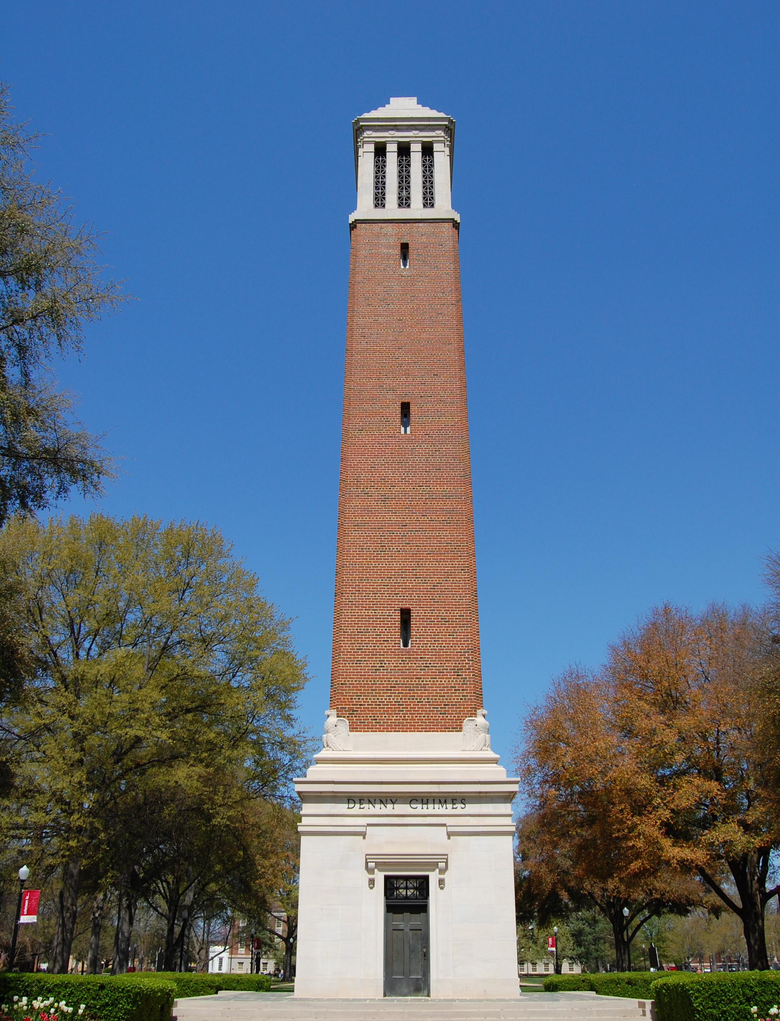
La Última Letra
of The UNIVERSITY OF ALABAMA
is proud to invite you to the Fourth Annual

Alabama Modern Language Conference
February 7th - 8th, 2014

The graduate students in the Department of Modern Languages and Classics are pleased to announce the fourth annual Alabama Modern Language Conference, to be held February 7-8, 2014, in Bidgood Hall on The University of Alabama campus. This year’s conference theme is
Converging Cultures: Languages, Literatures, & Identity

Keynote Speaker: Dr. Claire Kramsch
Professor of German and Education at the University of California, Berkeley; Author of The Multilingual Subject. What language learners say about their experience and why it matters. Oxford: Oxford University Press. 2009. Distinguished Teaching Award and Distinguished Service Award from the Modern Language Association, 2000.

When cultures engage, inevitably altering experiences, practices, and worldviews, new identities emerge. Multilingual and multicultural studies are vital to a fully informed approach to an array of disciplines. They affect our pedagogical approaches, our understanding of discourse, our interpretations of classic and modern literatures, and our appraisal of the evolution of culture, language, and interpersonal interaction. As critical participants in this process we invite you to showcase your insights concerning converging cultures.

We encourage graduate students in Spanish, French and German to present examples of how the domains of language, literature and identity interact and create new common ground.

We welcome submissions in the following categories pertaining to theme of converging cultures:
• Comparative literature, world literatures, emergent literatures
• Linguistics and language, hybrid speech
• Second language acquisition, applied linguistics, and culture in the classroom
• Post-Colonial and identity studies, multiculturalism, deconstructionist ideology
• Cultural studies, gender studies, topics on race, ethnicity and class
• Multi-disciplinary approaches in fields such as sociology, psychology, anthropology, and history

The conference welcomes papers in English, Spanish, French and German of 20 minutes in length. Please email abstracts in English of up to 500 words as a Word document attachment to amlc2014@gmail.com. Please include the following for each presenter: name, affiliation, e-mail address, title of presentation, and multimedia requests. Suggestions for panels of three or four presenters are especially encouraged; along with a description of the panel proposed, please submit individual abstracts for all presenters, and provide the professional information requested. The deadline to submit abstracts is November 15th, 2013. Information can also be found on our department website, mlc.ua.edu.

Box 870246 - 200 B.B. Comer Hall - Tuscaloosa, AL 35487

